Prep:
- Confirm contents of wagon:
  - Cord bag
  - Printer
  - Extra paper and ink
  - Camera and stand
  - Computer
  - Controller
  - Tablecloth and non-slip mat
  - Extension cord
- Screen

On Site Install:
- Plug everything in (use the power strip)
  - Screen
  - Computer
  - Printer (plug in power AND usb, insert tray)
  - Mouse
  - Keyboard
  - Camera (likely will put on tripod, set up about 3’ high (? *AV confirm) in the center of the screen
  - (*AV insert reference pic)
- Log in
  - User: demo
  - Password: etcdemo123
- For ease of setup, right click on taskbar (bottom bar with icons) head to taskbar settings. Under taskbar behavior uncheck automatically hide taskbar.
- Decide whether or not you will be using sound. If so, select proper source and set the volume to on, adjust later.
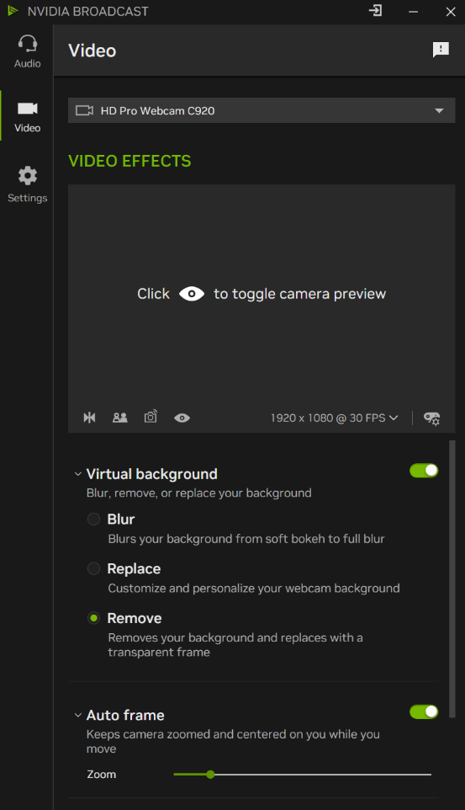
- Be patient, several applications open on start
- Open NVIDIA Broadcast window (opens automatically) and check options circled in red
- Open unity hub and open Unity_Project (*AV add file path for if it gets removed)
- The TouchDesigner (TD) file will open automatically
  - If closed find it (*AV nav)
- Final adjustments:
  - Full screen game mode
  - Adjust volume if using sound
  - Ensure wifi is turned off
  - Hide taskbar (see #6, check box)

Troubleshooting:
- First, go back through the list and double check:
  - Is everything plugged in?
  - Is wifi turned off?
- If ball tracking isn’t live on the gameboard:
- If it is not printing:
- If controller isn’t registering
  - (*HL, update when box v3 is done)

